Caring for Your Kitten

FEEDING - Many people have heard that dry food is the best food for your cat. It's better for their teeth, etc. We're learning that this is simply not the case. Feeding a primarily dry diet is suspected to lead to obesity, diabetes, hypothyroid, kidney failure and dental problems.

We feed our cats and kittens non-fish flavors of Fancy Feast canned food morning and night feedings (one can per meal). Pate or Grilled varieties. We mix in boiled chicken as an additional protein source.

Dry food provided at all times is Royal Canin Mother and Baby Cat and Farmina N & D chicken and pomegranate. We REQUIRE continuing to feed what the kittens are used to, as we have a proven track record with these foods. In the morning and evening I feed the equivalent of about 3 oz of canned food per adult cat/kitten. I have fresh water and dry food available at all times.

Whenever changing a cats diet, do it gradually by mixing a small amount of the new food in with what the cat is used to, increasing the amount of the new food daily. This will prevent the new food from causing intestinal distress. Table food, no matter what your cat wants you to believe, is neither necessary nor good for them.









LITTER BOX - The main rule is to keep whatever it is clean at all times. Scoop daily, both dry and wet material, and dump entire pan at least once a week. If you have more than one cat, you will need to change the litter box more frequently. Disinfect your box with Clorox bleach mixed 1:32 when you dump the pan. Let it soak for 10 minutes and wash it thoroughly. You may choose a covered or uncovered box, the covered ones tend to keep the litter inside with an overzealous digger. We use products called Precious Feline Unscented by Dr Elsey available at Petsmart. The odor control is unsurpassed. If you choose to change brands, do it by gradually mixing the Precious Feline with whatever clay litter you buy. Also, cats usually prefer the scoopable litter, if you want to use that follow the instructions on the container. Try to stay basic with your choice of clay litter, the scented ones can be overwhelming for some cats, they may choose a corner in the room instead. You cannot rule out a medical problem with a chronic mistake-maker. Remember, whatever type of litter pan you choose, whatever litter you use, whatever additives you put in it, THERE IS NO SUBSTITUTE FOR A CLEAN BOX.



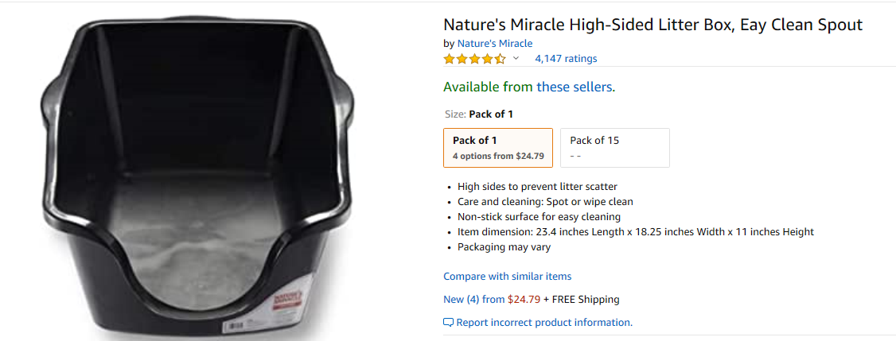

CLAW CARE- It is a natural instinct for a cat to sharpen it's claws. It exercises the muscles in the feet and removes the dead outer coat of the nail. A cats paw pads have scent glands on them which the cat uses as a way of "marking territory". You MUST provide your cat with a scratching post of some type. It needs to be tall enough and heavy enough that the cat can stretch out full length and scratch without pulling it over on top of them. The sisal rope (hemp) ones are recommended, as they last longer, and do not closely resemble the carpet on your floors and stairs. You may sprinkle dried catnip (which they might eat) on the scratching post to attract them to it. Your cat’s nails should be clipped once every 2 weeks. Be careful not to cut into the pink area of the claw, as it will cause pain to both your cat and your person. Once a cat has been "quicked" it never forgets. If your cat prefers your $2000 leather sofa to the scratching post, purchase a plant mister bottle or a child's squirt gun and spray the cat when you catch him. Do not make a big production out of it, don't say a word. For some reason, that way cats don't recognize YOU as the source of the water and therefore do not scratch the wrong stuff simply because you are not looking. If you scream "Fluffy!! Stop it!!! "before you squirt them, well then, they know you are behind it. Also, wide clear tape does not show on most furniture, and the cats can't stand the way it feels. If inappropriate scratching begins to be a problem, call me. It needs to be nipped in the bud, do not wait until it is an established habit!

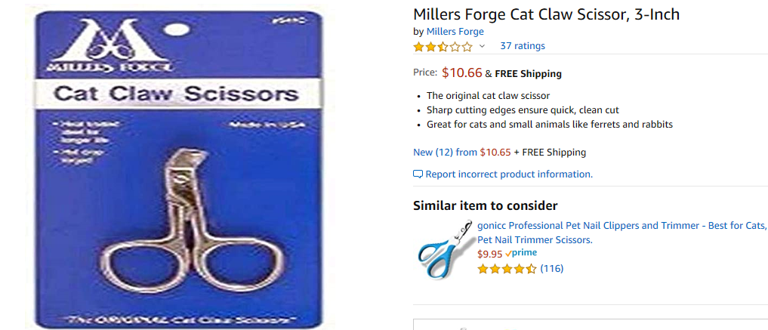

GROOMING - A Maine Coon is a shag coated (different lengths in different areas) cat. They do "Blow Coat" at certain times of the year, you will notice a lot of shedding. It is necessary that you comb the cat during these periods to remove the dead hair and prevent mats. The most common places for Coons to mat is in the underarm area, belly and britches (back of the thigh). Hairballs can also be caused from ingesting hair during normal grooming. They can cause deadly impaction in the intestines, not to mention wet gooshy things you tend to step in barefooted in the dark. Purchase a wide toothed metal comb for the majority of your grooming. Serious mats are best clipped out with electric clippers, a trip to the vet or groomer. Don't take your kitchen scissors and try to cut out any mats, a cat's skin is very thin and tears easily. A seam ripper, used for taking stitches out of fabric, can be *very carefully* used to remove mats from a cat. Always hold the seam ripper against your finger to keep from accidentally sticking the cat. Mats constantly pull against the skin, and can cause tearing of the skin and infection. (Think of how you would feel if you had your hair in a pony tail that was too tight and you could not take it out.)

Get your kitten accustomed to regular grooming and they will be easy to handle as adults.
A "lion cut" is a hairstyle that can be acquired from the groomers if you so choose.



FLEAS - We have been very fortunate not to have had any fleas here in recent years. They are horrid little creatures, almost impossible to kill! You can bring them in on your clothes, your dog can bring them in from the yard. If you see one, rest assured that there are at least 100. Fleas can cause anemia, tapeworm, skin problems and poor hair coat to name a few problems. A flea comb is great from removing individual fleas from your cat. Immediately FLUSH them. Chemical solutions for treatment of the house that I recommend are: Vet-Chem Siphotrol Plus Area Treatment. This comes in an aerosol can, can be purchased from your vet, and it is not necessary to remove the pets from the premises while spraying. For treatment of the animal itself, there are a few new products out on the market that are just applied topically with no bathing. Top Spot and Frontline by Mereux are preferred as they actually kill on contact, and each application lasts up to 3 months. Check with your veterinarian as to new information coming out on these products. Advantage and Program are also available, but their action is not as direct. There are documented cases of serious problems caused by Revolution and several of the Hartz Mountain products in cats.

TRAVELING & VACATIONS: While Maine Coons are highly adaptable and social animals, we feel that they are better off in their home environment as opposed to traveling with you. Cats do not adapt to new locations nearly as easily as dogs do. A dog will walk into a new room and immediately make themselves content, while a cat will become stressed and more than likely hide.

Boarding your cat at a local vet or boarding facility is certainly an option, however it is very stressful to the cat. We strongly suggest the services of a pet sitter, someone entrusted to come to your home while you are away and care for your cats. The cost is comparable with a boarding facility, and your precious one will have the comfort of their own surroundings, litter pan, food bowls and that special couch that they like to shed on while you are away.

GENERAL - Maine Coons like high places. Chairs, couches, beds, windowsills, etc. http://myweb/thebed122002.jpg. If you want to open your windows, be sure screens are secure, and open from the top only a few inches. Do not allow your cat on the kitchen counters even once unless you are prepared for such a habit. Put the cat on the floor and say NO. If the problem persists, try the plant mister. For health's sake, NEVER introduce another cat to this cat unless the other animal has been tested by a veterinarian for Feline Leukemia, Feline Aids, parasites, and general health! If down the road you want to introduce another cat into your home, please refer to the sheet enclosed with this package called "Introducing your new Cat/Kitten into your home."
DANGER- Do not leave strings, twist ties, rubber bands, sewing materials, paper clips, used dental floss etc. about. *ALL* of our trash cans are covered. Do not let your cat rummage in the garbage. Various houseplants are poison to cats. Always check your dishwasher, clothes washer and dryer before operation. For some reason, cats are very attracted to plastic and paper bags from grocery stores, and usually try to stick their head through the handles. If they are successful, it results in a terrified cat running away from something that's closely following it and doesn't go away. They can be injured as a result! Please make sure that you put all bags out of their reach! Maine Coons are intelligent, and curious. Take precautions.

INTRODUCING YOUR NEW KITTY
THERE IS A VERY SIMPLE, FAIRLY PAINLESS METHOD TO INTRODUCE A NEW KITTY.
HERE IS THE PROCEDURE:
"Furnish" a room for the New Kitty to come home to. This is where he/she will spend 3-8 days getting to know YOU and your family. Provide food, water, litter pan, a few toys, a scratching post and a "bed". The bed can be an old comforter folded to make a nice soft bed to snuggle in, an old sweatshirt or two, or a couple nice thick towels folded.
Give the New Kitty some toys: balls with bells, catnip-filled toys, & furry mice. Have a couple feather toys placed out of the New Kitty's reach too. These come in handy for if the New Kitty gets frightened and goes under a piece of
furniture. They usually can't resist.
When you come home with the New Kitty, take him/her to "his/her room". Place the carrier near the litter pan - this is a reference point he/she needs to know immediately, before anything else happens, where the litter pan is located.
Open the door to the carrier - let him/her come out when he/she is comfortable. Some come out immediately, tail waving, head up - looking around to explore. Others will slink out, and go under something. This is ok - just talk softly to the kitty, put food in the dish, and leave him/her alone for a little while, to listen to the new noises and smell the different smells in your house.
Go in several times during the first day - the New Kitty may not run up and leap on your lap - so please don't be disappointed. He/she's very much out of his/her known territory. So what do you? Go into the New Kitty's room, sit down, and talk, watch TV or read a book, and talk to the New Kitty. The New Kitty may or may not come out. If he/she does, that's great, and shows he/she will probably not need the full 8 days in the room.
Second day & Third day, same routine. Go in before leaving for work, give fresh food / water, scoop the litter pan - the New Kitty should now have nibbled and used the pan. Some will wait about 24 hours; others have no qualms at all. When you arrive home from work, go visit the New Kitty. Get down on the floor and entice him/her to play. (This is where the feather toys come in handy.) On each trip to visit the kitty, notice if the balls or any other toys have been moved or anything else in the room. If things have been disturbed, that means he/she has been exploring.
I cannot emphasize enough how much patience may be needed during the first couple of weeks with a New Kitty. An older adult may require much more time and patience.
Fourth day - pick up the New Kitty, and open the door. Allow the Existing resident Cat (ERC), if you have one, to come in, while you go out and close the door. Allow about an hour or so for the ERC to sniff and investigate where the New Kitty has been. During this time, take the New Kitty to where the ERC's litterbox is (again, a reference point) - and allow the New Kitty to explore at his/her own pace from there. Then, exchange the New Kitty and ERC again - New Kitty back to "his/her" room, ERC back into "his/her" house. Do this 1-2 more days. The New Kitty should become increasingly comfortable, and this is the best way to prevent the ERC from taking great offense that another creature has moved in.
On the 6th or later day - when you arrive home, go in and spend a little time playing with the New Kitty. When you exit the room, leave the door open. For a few more days, leave the New Kitty's litter pan and dishes in the room - then
remove them. The New Kitty should be using pans in both locations, and should not mind the removal of "his/her".
THE BENEFITS OF INTRODUCING A NEW KITTY IN THIS MANNER
1. The New Kitty gets used to new sounds, smells and people in a confined area, and this area is likely to be a comfort zone if for some odd reason later on in life, he/she gets frightened by something or must be confined.
2. It allows observation for both you and the New Kitty. You can see what the New Kitty likes in regards to toys, petting, and grooming, plus it gives you a chance to see how much he/she's eating, and using the litter pan for the first week and just generally observe his/her general behavior. The New Kitty is given a chance to get to know and bond with you, without interference from the ERC. Take your time, allow the New Kitty to progress at his/her own pace. It’s well worth the time spent!
And remember, this could take a few days, weeks or even months. Just do not get discouraged.

